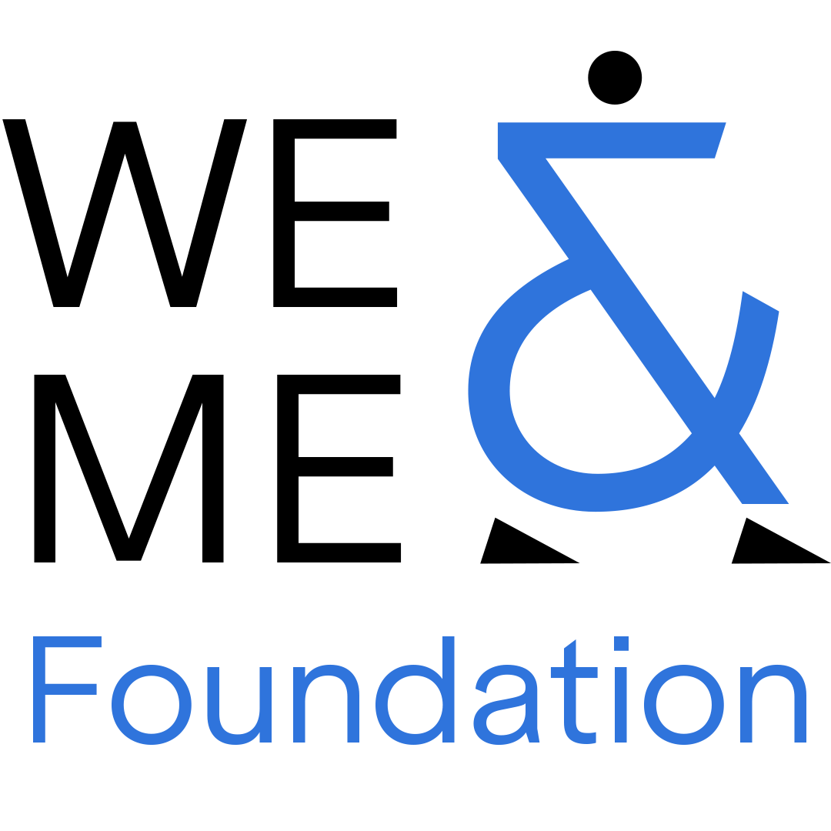

WE&ME
Emerging Leader Award
Applicant  (Institution) | Please fill in
Nominator  (Institution) | Please fill in

###delete this paragraph###
The bold headings are mandatory. Each subheading must be addressed explicitly, in a format and order of the applicants’ choosing.
Use a common font type (such as Arial, Source Sans Pro) and font size 11pt. Line spacing should be between 1.3 and 1.5. Do not add any headers or footers. Figures, tables, etc. may be included. Candidate section (approx. 1.5 pages) and Nominator section (approx. 0.5 pages). A final PDF of a maximum of 2 pages plus cover page, is permitted.

###delete this paragraph###

Candidate section

Short bio

Your engagement with ME/CFS

Most significant scientific contribution to date

Use of the award funds

What is the research question in this field that you most want to see answered in the next five years?

Nominator section

Short bio of the nominator
Short Statement

